1. In the SAP easy access menu type SE38 and press enter.

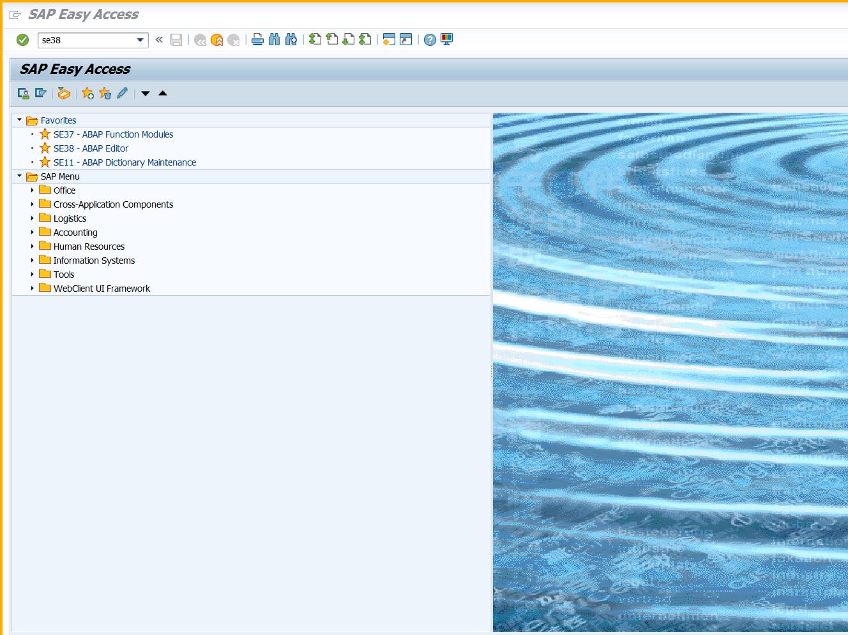

1. Enter program name as shown below.

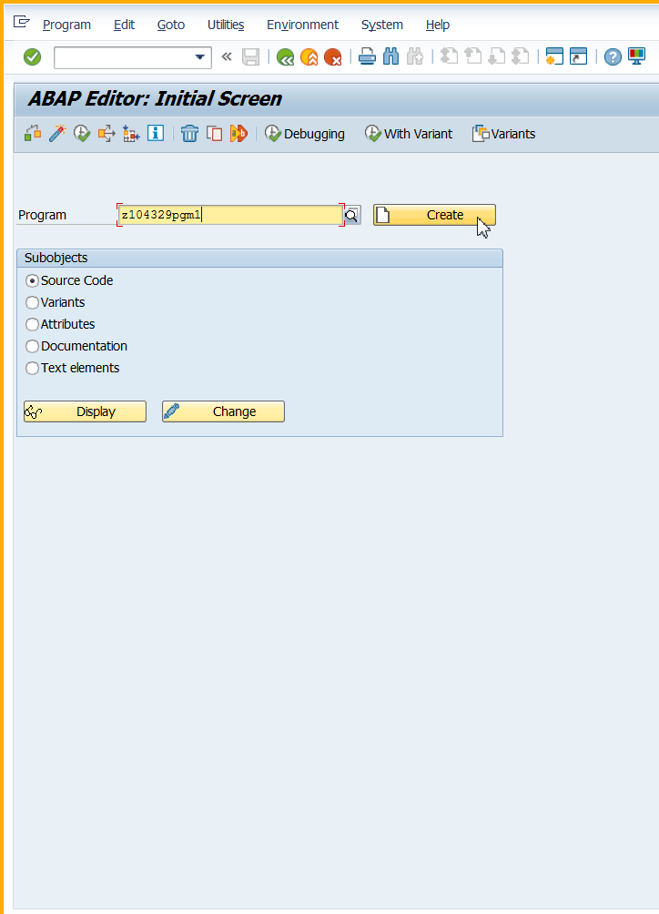

Name of program is zxxxxpgm1

Where xxx is your empcode

1. Enter title and select type executable.

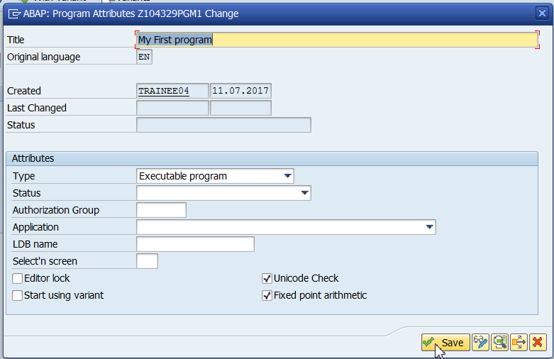

Click on save.

1. Enter package as shown below and click on save icon.

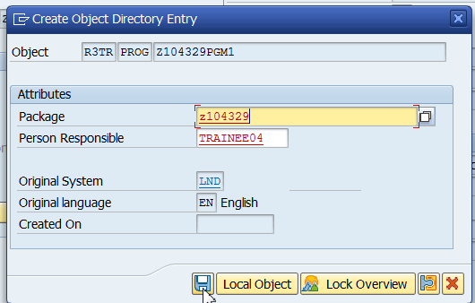

1. Check the program.

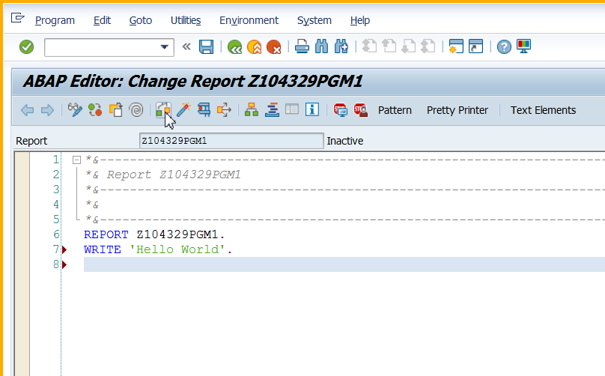

1. Save the program

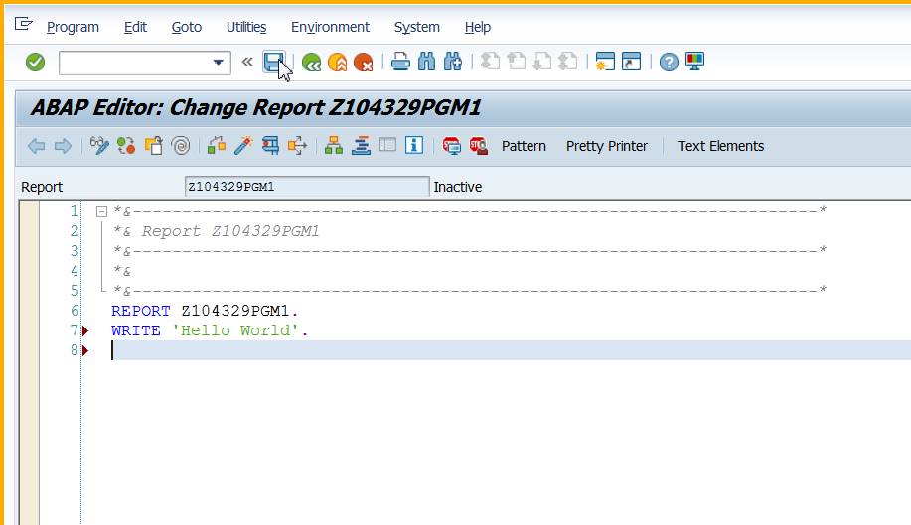

1. Execute the program

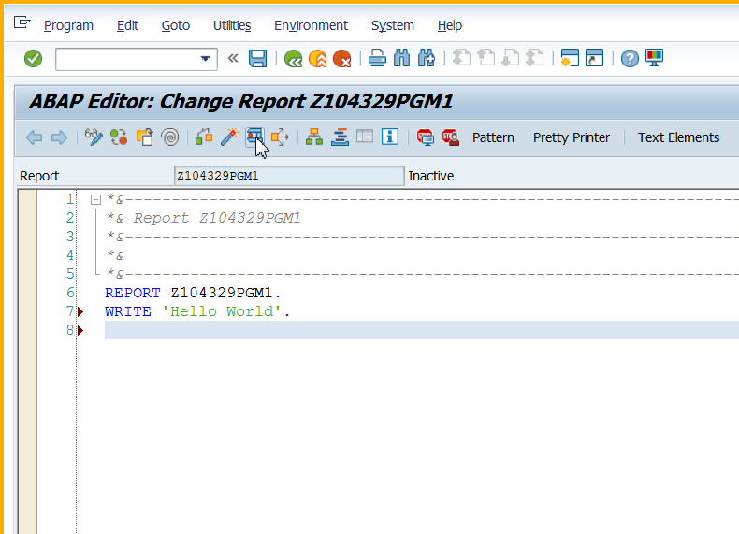

1. See the output

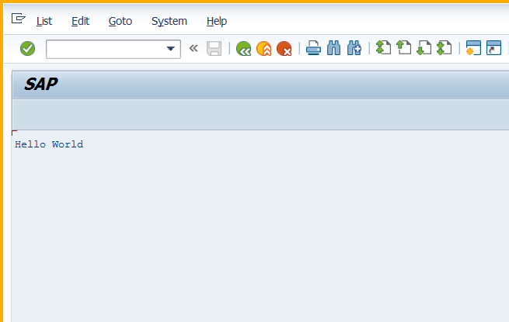

1. Press the back button to go back to the editor window.

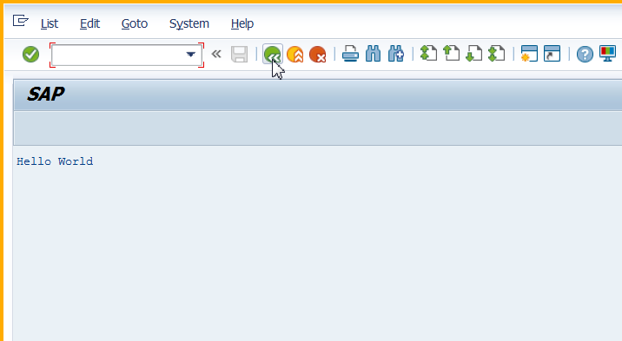

1. Back to editor window.

